- Design
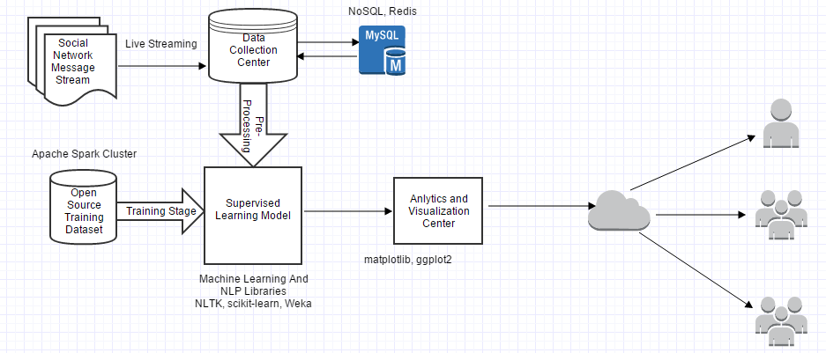

Sentiment Analyser consists of an incoming live data stream from various social media such as Facebook, Twitter, WordPress, Blogger, Flipboard on the application.
Once the data arrives it is stored in Data Collection Centre which is then processed by a semi-structured data processing tool such as NoSQL and MongoDB to parse the data which is the form of JSON so as to extract only the required textual information.
In-Memory caching is used by redis which provides optimal hashing for faster data retrieval.
The stored data is then pre-processed to take pictures, emojis, external links into consideration and passed on to the Supervised Learning Model.
The machine learning model is trained previously with open source data for classification of data based on sentiment. The data post-classification is passed on the Analytics and Visualization Centre which then generates a personalized report with various graphs depending on the requirement.
The report is then exposed to public using internet which can be accessed using HTTP requests.
